Ministry of Education
General Direction of Institutes and Training
PESHANG INSTITUTE – Erbil

Kurdish AI

A project Submitted to the Computer Science & IT Department Peshang Institute – Erbil
In the Partial Fulfillment of the Requirement for the Degree of Diploma of Science Computer Science & IT

Prepared By:
Halwest A Qader
Hardi A Qader
Hiba J Jalal
Nawaz Askandar
Sharif K Maruf
Supervised By:
Awdang Aziz

Kurdistan,Erbil (Feb -2025)

بِسْمِ اللهِ الرَّحْمنِ الرَّحِيم

{ وَأَنزَلَ ٱللَّهُ عَلَيۡكَ ٱلۡكِتَٰبَ وَٱلۡحِكۡمَةَ وَعَلَّمَكَ مَا لَمۡ تَكُن تَعۡلَمُۚ وَكَانَ فَضۡلُ ٱللَّهِ عَلَيۡكَ عَظِيمٗا }

صّدٍقُ آلَلَهّ آلَعٌظُيَمً
النساء - الآية 113

Dedication
Dedicated to:
- Our parents who support us till the day we close our eyes.
- Our family members and friends who supported us during good and bad times.
- Full Name our supervisor that guided us from beginning to the end.
- Other Teachers that helped us out when we had unanswered questions.
- Our siblings who always helped and supported us.
- Our classmates who made this journey fun and special.
- The institute staff who gave us what we needed.
- Our mentors who pushed us to do our best.
- The researchers who helped us understand our topic.
- The staff who helped us with paperwork.
- Our colleagues who shared what they knew.
- Everyone who helped us succeed.
- Those who made us think in new ways.
- Future students who will read this work

Certificate

I certify that the project titled "Kurdish AI" was done under my supervision at the Computer Science and IT Department, Peshang Institute. In the partial fulfillment of the requirement for the degree of Diploma of Computer Science and IT.

Supervisor

Signature:
Name: Awdang Aziz
Date: 13/2/2025

Abstract

The Kurdish AI project helps people talk to computers in Kurdish. It makes it easy for Kurdish speakers to use AI technology in their own language. The system can
read and understand Kurdish text, and give helpful answers back in Kurdish. It works on phones and computers, making it simple for anyone to use. The project helps Kurdish students learn, businesses work better, and keeps the Kurdish language strong in the digital world. It can understand different types of Kurdish and learns to give better answers over time. This project brings Kurdish language into modern technology, making sure Kurdish speakers can use digital tools just like any other language. It helps preserve Kurdish culture while making new technology accessible to Kurdish communities everywhere.

Table of Contents
Chapter | Page
Contents
Dedication 2
Certificate 3
Abstract 4
Table of Contents 5
Table of Tables 7
Table of Figures 8
Table Of Abbreviation 9
Chapter One 10
Introduction 10
1.1 Introduction 11
1.2 Aims & motives 12
1.3 Related works 13
Chapter Two 14
Methodology 14
2.1 Hardware requirements 15
2.2 Software requirements 16
2.3 Use case diagram 17
Chapter Three 18
3.1Analysis and Design 19
3.2Implementation 20
3.3 Interface of the project 21
3.4Home Page 22
Chapter Four 24
24
4.1Chat 25
4.2Chat Section 26
4.3 Speech to Text 27
4.4 Telegram Chat Save 28
4.5Costs of Project 29
Chapter Five 30
Conclusion 30
4.6References 31
Appendix 33
پوختە 34

Table of Tables

Table 1 Table of Abbreviation 9
Table 2 Hardware Requirements 15
Table 3 Cost of Project 29

Table of Figures

Figure 1 Diagram 17
Figure 2 Flowchart of Project 19
Figure 3 Signing Page Error! Bookmark not defined.
Figure 4 Signup Page Error! Bookmark not defined.
Figure 5 Home Page with Sorani 22
Figure 6 Home Page with Kurmanji 22
Figure 7 Chat Section 26
Figure 8 Record Button 27
Figure 9 Send Record 27
Figure 10 Add Telegram 28
Figure 11 Telegram Setup 28

Table Of Abbreviation
Abbreviation | Description
AI | Artificial Intelligence
CSS | Cascading Style Sheet
JS | Java Script
HTML | Hypertext Markup Language
VS Code | Visual Studio Code
API | Application Programming Interface
SSL | Secure Sockets Layer
RDP | Remote Desktop Protocol
RTL | Right To Left
VPS | Virtual Private Server
VENV | Virtual Environment
DB | Database

Chapter One

Introduction

1.1 Introduction

Adding Kurdish language to AI is an important step to help Kurdish speakers use new technology. Our project helps Kurdish speakers by making an AI that can understand and speak Kurdish. Today, we use technology for many things, but Kurdish speakers often can't use many digital tools because they don't work in Kurdish. Our project fixes this by making an AI that works in Kurdish.
When Kurdish speakers can't use technology in their language, they face many problems. Our project helps solve this by making AI work in Kurdish. This means Kurdish speakers can use technology without having to use another language.
- Find information online in Kurdish
- Study in Kurdish
- business in Kurdish
- Use AI tools in Kurdish
- Make Kurdish content
This project doesn't just make a tool - it helps Kurdish speakers be part of the digital world while using their own language. We made the AI learn Kurdish words and rules. It also learns about Kurdish culture to give good answers.
Source taken from: Anthropic Company: https://console.anthropic.com

Aims & motives

The main goals of this project are:

First time Building an AI system that can read and answer in Kurdish, making it easy for everyone to use Helping Kurdish speakers have the same access to technology as other languages, Making learning easier by providing help in Kurdish, Keeping Kurdish language strong and active in the digital world
Why we are doing this project:
Right now, most AI systems don't work with Kurdish
Schools and students need more digital tools that work in Kurdish
We need to keep Kurdish language alive and growing as technology advances,
Kurdish communities should be able to use modern technology easily.

1.3 Related works
Similar projects that help Kurdish language and technology:
This project involves a chat assistant that can understand and respond in Kurdish language, making AI technology accessible to Kurdish speakers. A similar existing system in this field is Kurd.ai, which was an early pioneer in Kurdish language AI assistance.
The key aspects that make these systems noteworthy for Kurdish language technology:

Natural Language Processing: These systems can process and understand Kurdish text input
Language Generation: They can generate responses in proper Kurdish language
Cultural Context: They understand Kurdish cultural references and context
Local Language Support: They specifically focus on making AI accessible in Kurdish
These systems represent important steps in developing AI technology that serves Kurdish-speaking communities and helps preserve and promote the Kurdish language in the digital age.
These systems represent important steps in developing AI technology that serves Kurdish-speaking communities and helps preserve and promote the Kurdish language in the digital age.

Chapter Two

Methodology

Hardware requirements

Hardware | Description
Server | • Processor: Intel Core i7  • RAM: Minimum 4 GB  • Storage: 128 GB SSD  • Shared  • VPS
Computer For Development Environment | • Processor: Intel Core i5 or AMD Ryzen 5 (or better)  • RAM: Minimum 8GB (16GB recommended)  • Storage: 256GB SSD or HDD  • Internet: Stable connection with minimum 10 Mbps speed  • Display: 1920 x 1080 resolution or higher

Table 2 Hardware Requirements

Software requirements

Software | Description
JS | Programming Language
React Vite | Frontend Framework of JavaScript
Firebase | DB management
Python | Programming Language
Anthropic API | API Used to Integrate with Chat Input
PyCharm | Integrated Development Environment
Sonnet | AI Model Used to Integrate with Chat Box
Table 3 Software Requirements

2.3 Use case diagram

These features allow users to interact with the chat system, manage their conversations, and choose their preferred language. The interface designed with user-friendliness in mind: 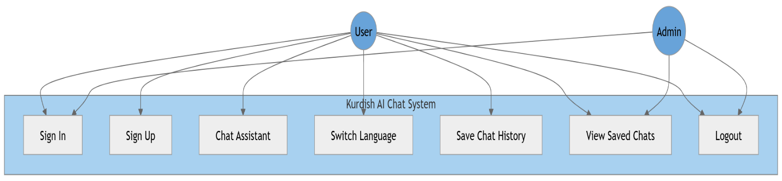

Figure 1 Diagram

- Sign In
- Sign Up
- Chat Assistant
- Switch Language
- Save Chat History
- View Saved Chats
- Logout

Chapter Three

3.1Analysis and Design

The following figure shows the flowchart of the project:

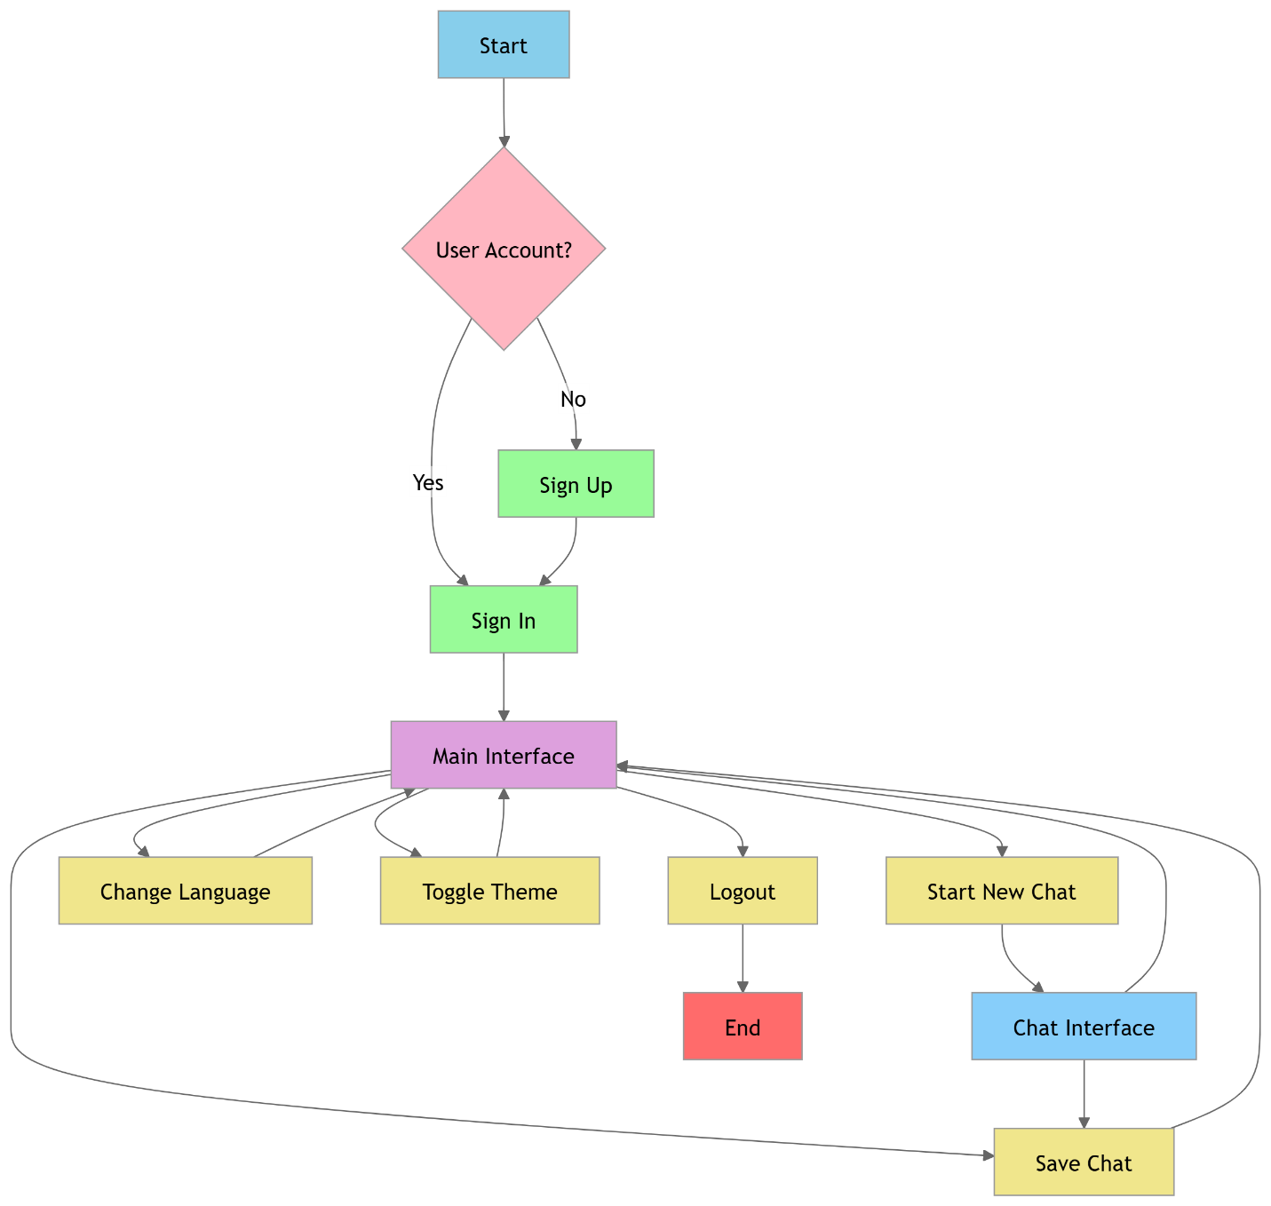
Figure 2 Flowchart of Project

3.2Implementation

Intelligent Chat Assistant with Sorani and Kurmanji Accents Experience the next level of AI-powered conversation with our smart chat assistant, designed to understand and respond in both Sorani and Kurmanji Kurdish. Whether you prefer speaking in Sorani or Kurmanji, the assistant effortlessly adapts to your language choice, providing a smooth and natural interaction. The Kurdish AI Chat System provides a user-friendly interface where users can sign in or create new accounts to access the chat assistant. The system offers a seamless language switching feature allowing users to communicate in their preferred Kurdish dialect. Users can save their chat history for future reference and access their previously saved conversations through the view saved chats feature. The system includes a simple logout option for security. The interface is designed with a clean blue and white color scheme, making navigation intuitive and straightforward for all users, that is the figure 3.

3.3 Interface of the project
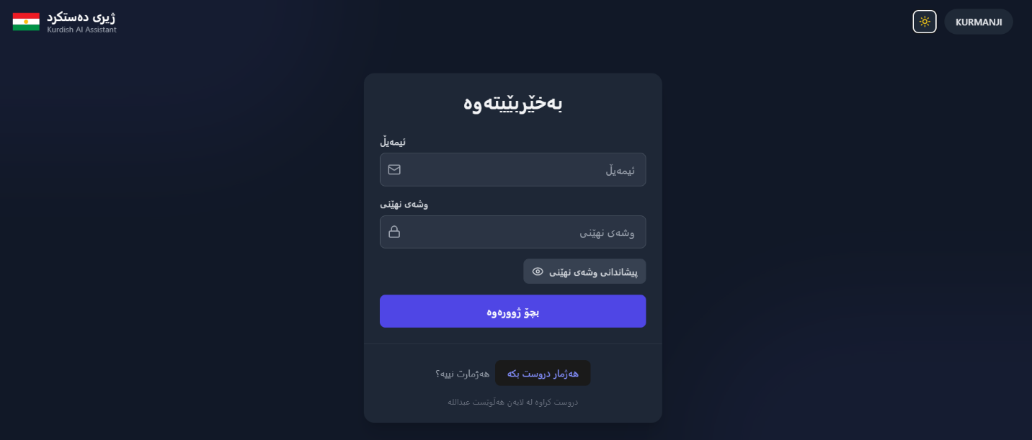
It is a login form with a very friendly design
3.2 Login Page
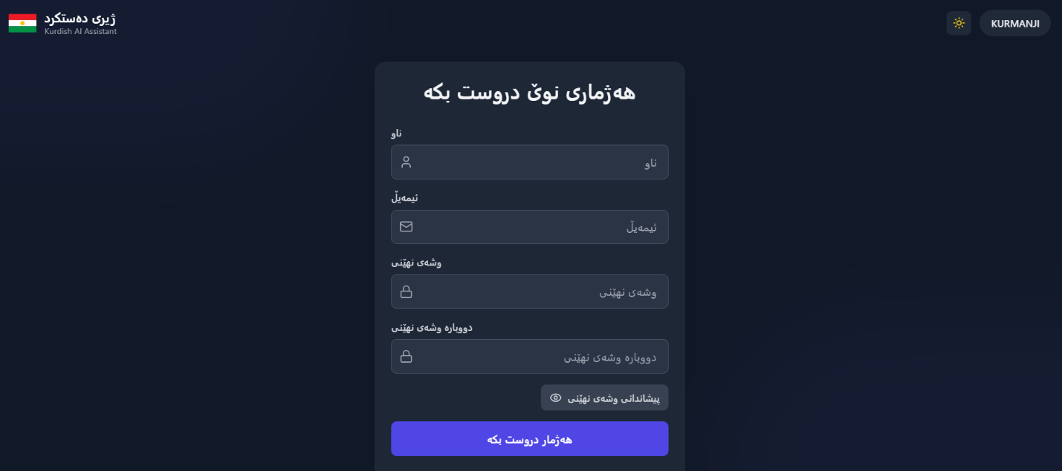
The registration form consisting of these options must be completed

3.3 Registration Page

This is the login and registration section

3.4Home Page

This is the main part of the system that on the left side bar contains several options such as change language, change mode, add chat, update, exit button Below are several sections: Text Box, Add Telegram, Audio Recording
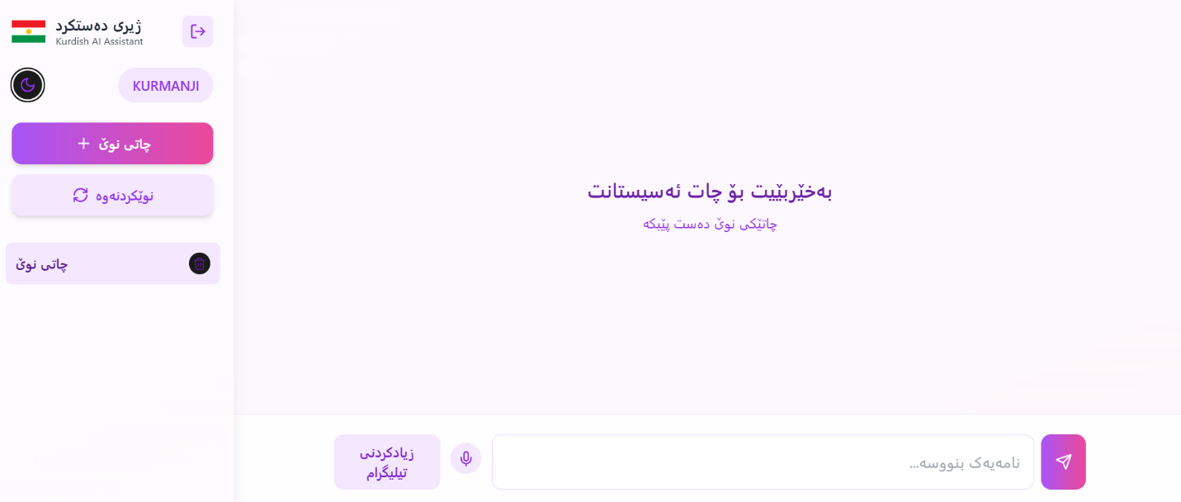
Two accents are also available, Sorani and Kurmanji
Figure 3 Home Page with Sorani
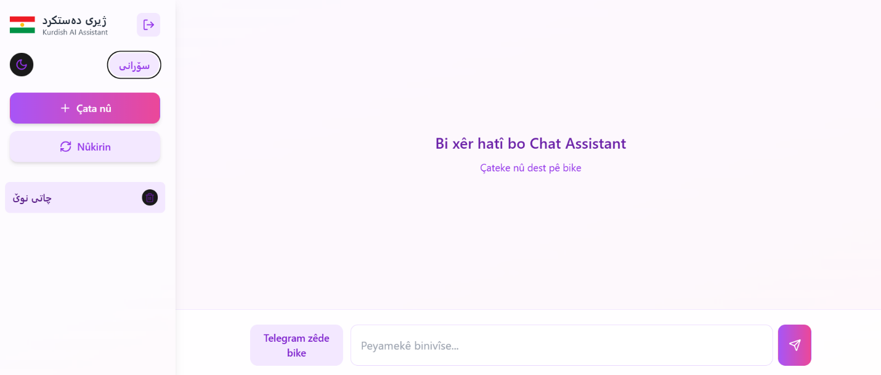
Figure 4 Home Page with Kurmanji

Figure 6 Home Page with Kurmanji

Chapter Four

4.1Chat

Messaging or chat assistant app, with a purple color scheme. At the top, there's text in Kurdish that seems to be introducing the assistant and explaining its capabilities. At the bottom of the screen, there's a message input field with Kurdish placeholder text "نامەیەک بنووسە..." (which means "Write a message...") and some controls including what appears to be a voice input button and a send button.
The visual design is clean and modern, using a light background with purple accent colors. This seems to be an example of a chat assistant that's been localized to support Kurdish language users, making technology more accessible to Kurdish speakers.

4.2Chat Section
There is text box where you can type anything into it and it can reply you on any specific topic
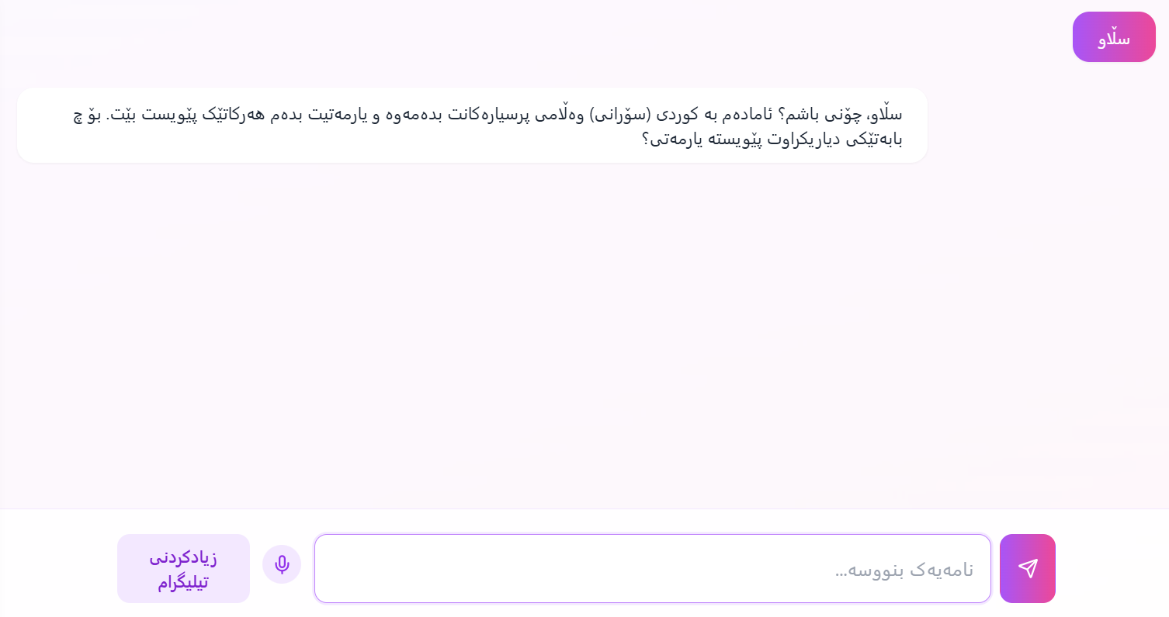

Figure 5 Chat Section

4.3 Speech to Text
there's a voice input feature that works directly with the chat. When you press the microphone button and speak in Kurdish, the after that Click on send "ناردن" converts your speech into written Kurdish text and places it right in the text input box.


Figure 6 Record Button

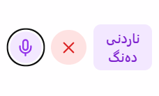
Figure 7 Send Record

4.4 Telegram Chat Save

This tool connects your chat with Telegram in a very simple way. When you press the "Add Telegram" button, you'll first need to join their bot. After joining the bot, the system will ask you to get your Telegram ID. You enter this ID in the designated text box. Once that's set up, anything you write in the chat box will be automatically sent to your Telegram account.
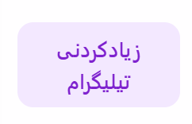
Figure 8 Add Telegram

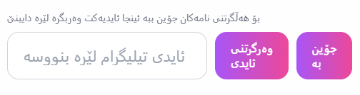
Figure 9 Telegram Setup

4.5Costs of Project

It cost so much to build this project
SERVICES | COST
API | 25$
SERVER | 65$
DOMAIN | 10$
SSL | 5$

Table 4 Cost of Project

Chapter Five

Conclusion

5.1References

Websites:
1. Anthropic: https://console.anthropic.com/ - December 20, 2024
2.Pawan: https://pawan.krd/ - December 5, 2024
3. Vite Dev: https://vite.dev/guide/ - October 2, 2024

Articles:
1. " https://kurdistanchronicle.com/babat/2872 " by Kurdistanchronicle - October 7, 2024
2. "https://www.researchgate.net/publication/371403000_Kurdish_Studies_Analysis_of_Artificial_Intelligence_Adaptation_in_Students_of_Kurdish_Universities" by Research Target - October 11, 2024

Additional Resources:
1. Kurd AI: https://kurd.ai/ - November 12, 2024
2. Odoo: https://www.odoo.com/ - October 22, 2024
3. ChatGPT: https://chatgpt.com/ - October 5, 2024

Books:
1. AI with Python: https://www.pdfdrive.com/ai-with-python-e56913512.html - December12, 2024
2. Python Artificial Intelligence Projects For beginner:https://www.pdfdrive.com/python-artificial-intelligence-projects-for-beginners-get-up-and-running-with-artificial-intelligence-using-8-smart-and-exciting-ai-applications-e183992068.html - December 8, 2024
3. Deep Learning Using R: https://www.pdfdrive.com/introduction-to-deep-learning-using-r-a-step-by-step-guide-to-learning-and-implementing-deep-learning-models-using-r-e158252417.html - December 12, 2024
4. Designing Web APIs: https://www.pdfdrive.com/designing-web-apis-building-apis-that-developers-love-e176234255.html - October 22, 2024

Appendix

That is the main method to get data between Client and Server:

const response = await fetch('https://Server Domain/end points', {
method: 'POST',
headers: {
'Content-Type': 'application/json',
'Server-Api-Version': '2023-06-01',
'x-api-key': 'API KEY'
},
body: JSON.stringify({
model: "claude-3-sonnet-20240229", //AI Model
max_tokens: 1024,
messages: [
{
role: "user",
content: req.body.message
}
],
system: "You should respond in Kurdish (Sorani) unless specifically asked otherwise."
})
});

پوختە
ئەم پڕۆژەیە کاردەکات لەسەر گەشەپێدانی سیستەمێکی ژیری دەستکردی تایبەت بە زمانی کوردی کە توانای گفتوگۆ و بەرسڤدانەوەی بە زمانی کوردی هەیە. ئامانجی سەرەکی پڕۆژەکە بریتییە لە بەرەوپێشبردنی زمانی کوردی لە بواری تەکنەلۆژیادا و دروستکردنی پردێک لە نێوان تەکنەلۆژیای نوێ و زمانی کوردیدا.
تایبەتمەندییە سەرەکییەکانی ئەم پڕۆژەیە بریتین لە پشتگیری تەواوی زمانی کوردی، ئینتەرفەیسێکی ئاسان بۆ بەکارهێنان، توانای تێگەیشتن و وەڵامدانەوە بە زمانی کوردی، و گونجاو بۆ هەموو ئاستەکانی بەکارهێنەر.
بەکارهێنانی ئەم سیستەمە دەبێتە هۆی فێرکردن و فێربوونی زمانی کوردی، یارمەتیدانی بەکارهێنەران لە کارە ڕۆژانەکانیان، پەرەپێدانی توانای زمانەوانی، و دروستکردنی پەیوەندی نێوان نەوەی نوێ و زمانی کوردی.
گرنگی پڕۆژەکە لەوەدا دەردەکەوێت کە یەکەم هەنگاوە بۆ دروستکردنی ژێرخانێکی تەکنەلۆژی بە زمانی کوردی، یارمەتیدەرە بۆ پاراستن و گەشەپێدانی زمانی کوردی، دەبێتە هۆی زیادکردنی بەکارهێنانی زمانی کوردی لە دنیای دیجیتاڵدا، و دەرفەتی نوێ دەڕەخسێنێت بۆ فێربوون و پەرەپێدانی زمانی کوردی.

